Alberto Clocks

|  |  |  |
| --- | --- | --- |
| **Supervisor.** | **Sir Ebad Uddin** | |
| **Batch.** | **2210E1** | |
| **Group.** | A | |
| **Serial No.** | **Enrollment Number** | **Student Name** |
| 1. | 1424649 | Tayyaba Muslim |
| 2. | 1426353 | Mutayba Kamran |
| 3. | 1425430 | Muhammad Talha |
| 4. | 1425319 | Khula Amjad |

**ACKNOWLEDGEMENT**

Some of the benefits of eProjects are as under: -

1.    Re-enforcement of Skills happens in the experiential learning process.

2.    A mentor, ensuring that you do not get drifted, constantly guides you.

3.    It gives you a lot of confidence to face an interview as you have worked on a project. You can explain virtually everything on the subject you have learnt.

4.    A nice, final, black, hardbound report adds to you credentials and enhances your job prospects.

eProjects is compulsory (Sem-End Project) and is supposed to be done over and above the assignments given in your course books.

It is advised that if a student follows the projects and submits assignments he would definitely have an edge over other students.

Students need to submit their project report along with working application and source code in the stipulated time.

Projects will be evaluated.

***SYNOPSIS***

Alberto Clocks is a website that specializes in selling clocks of various types. The website features a wide range of clock designs that are suitable for different purposes, including wall clocks, alarm clocks, digital clocks, and desk clocks.

The website provides customers with detailed descriptions and images of each clock, allowing them to make an informed decision when choosing a product. In addition, the website offers a secure and easy-to-use online shopping experience, with a range of payment and delivery options available.

Alberto Clocks is known for its high-quality products and excellent customer service. Customers can reach out to the company's support team for any questions or concerns they may have about their purchase, and the team is always happy to help.

Overall, Alberto Clocks is a reliable and trustworthy website for anyone in the market for a new clock. With a wide selection of designs and top-notch customer service, customers can feel confident in their purchase and enjoy their new clock for years to come.

Top of Form

***PROBLEM DEFINITION***

* Alberto Watch Company is a full-service watch repair, appraisal, and retail store offering the finest selection of luxury timepieces. Offering an unparalleled selection with first-class service.
* Alberto also carries a wide selection of brand new watches such as Michael Kors,
* Rolex, Citizen Eco-Drive, Bulova and more!
* You are supposed to create a Single-Page-Application and responsive Website for them with the below mentioned - requirement specifications.
* The website is to be developed for the Windows Platform using HTML5, JSON,
* Angular JS, JavaScript and Geolocation. The site should work well in all leading browsers including Chrome, IE, Firefox etc.

***CUSTOMER REQUIREMENT SPECIFICATION (CRS)***

The Web site is to be created based on the following requirements.

1) The Top of the Page should be presented with a suitable logo, and page

should have decent color combination.

2) The site should display a menu which will contain the options as Products,

Technology, Store Locator, Support etc.

3) Various sections having information about different types of watches and clocks, Technology used in the watches etc. these sections should display products accordingly.

4) The information should be categorized in sections according to different

Product Line-up e.g. “Vintage”, “Luxury”, “Smart Watches” etc.

5) When a user selects any product line-up, complete list of watches for that

product line-up will be displayeds.

6) Details of the watches should be displayed on the popup window.

7) Price List for all watches should be available.

8) Gallery can be added for viewing different images.

9) Site map, Gallery, about us, Contact us link must be added.

10) About Us and Contact Us: This menu option should display Email id, address, and contact number of the organization.

Over and above this, the portal should implement the following functionalities:

* Display a visitor count at the top right corner of the page beside a logo image.
* The menu options should change color on hover and also after clicking.
* Fade in and fade out options can be used for the menus.
* Display a continuous scrolling ticker at the bottom of the page with current date,time, and location (hint: Use geolocation features of HTML5).

***SCOPE OF THE WORK (IN BRIEF)***

The thirst for learning, upgrading technical skills and applying the concepts in real life environment at a fast pace is what the industry demands from IT professionals today. However busy work schedules, far-flung locations, unavailability of convenient time-slots pose as major barriers when it comes to applying the concepts into realism. And hence the need to look out for alternative means of implementation in the form of laddered approach.

The above truly pose as constraints especially for our students too! With their busy schedules, it is indeed difficult for our students to keep up with the genuine and constant need for integrated application which can be seen live especially so in the field of IT education where technology can change on the spur of a moment. Well, technology does come to our rescue at such times!!

***AGGREGATED SITEMAP***

***SITEMAP ENGLISH***

(1.In



***WIREFRAMES***

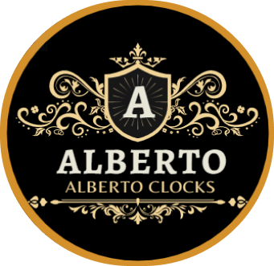 Home About Gallery Menu ClockCatalog Product Contact

NAVBAR:

Menu:

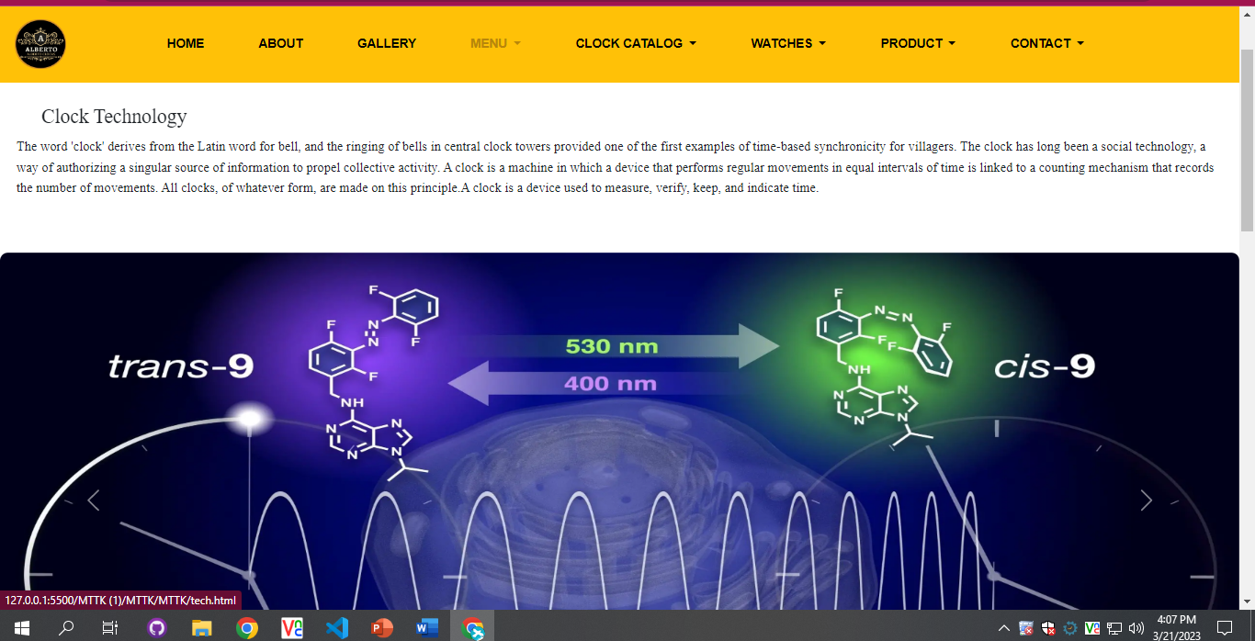

PICTURE

Products:

OUR PRODUCTS

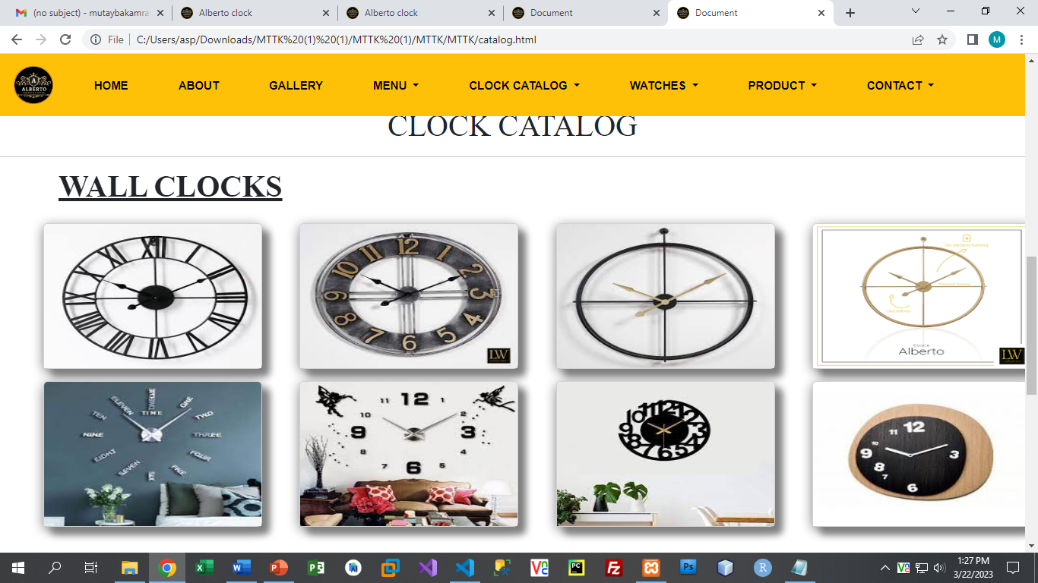

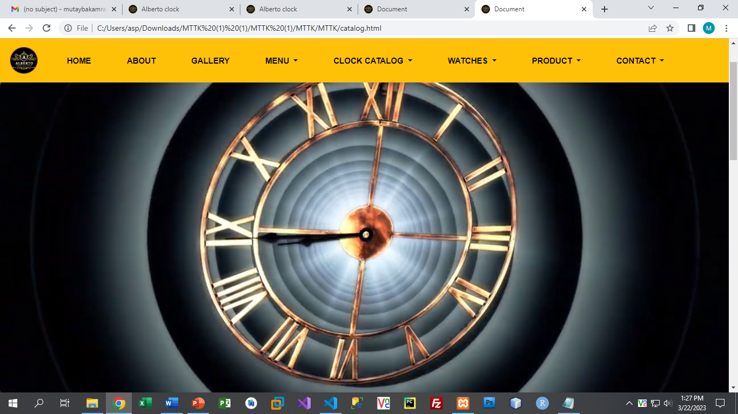

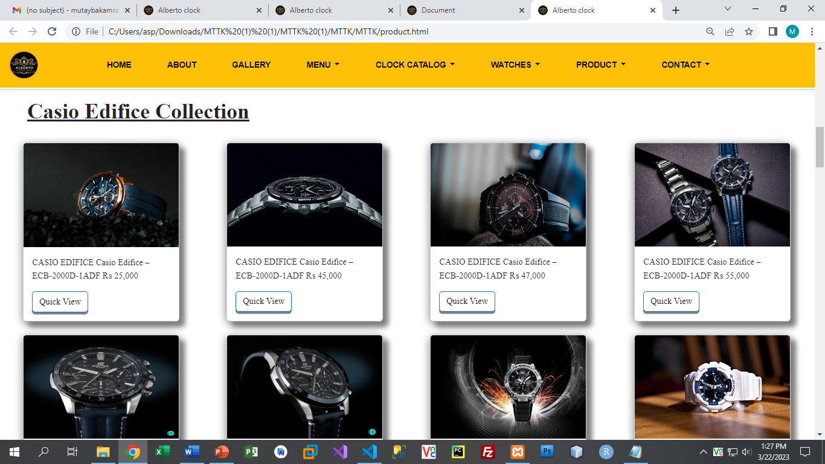

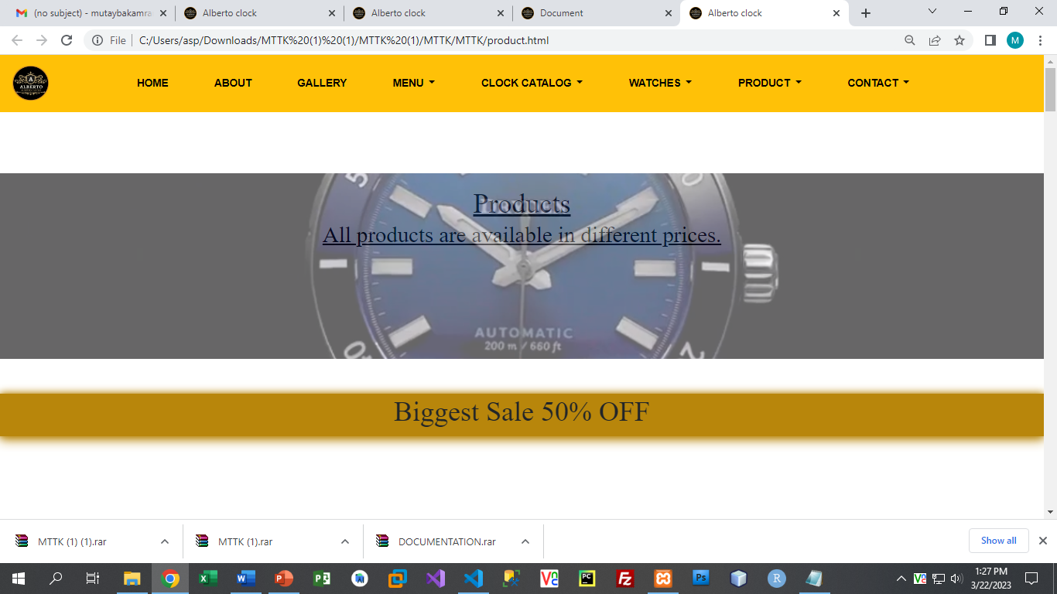

PIPP

# 

Products:

NEW ARRIALS

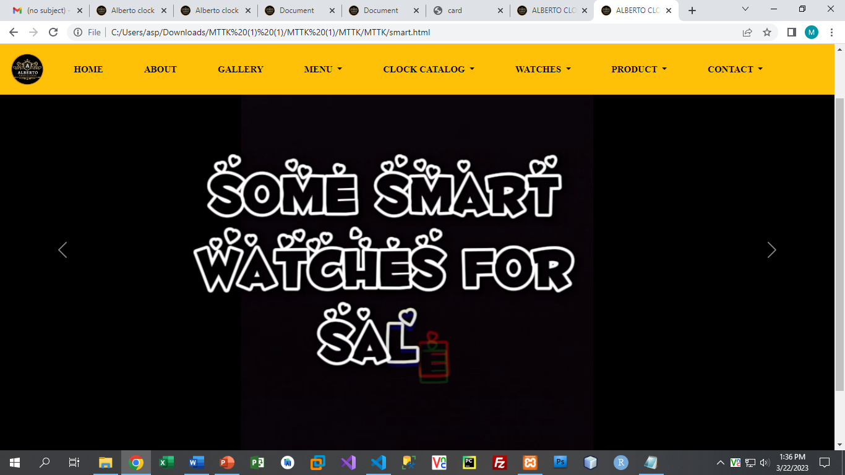

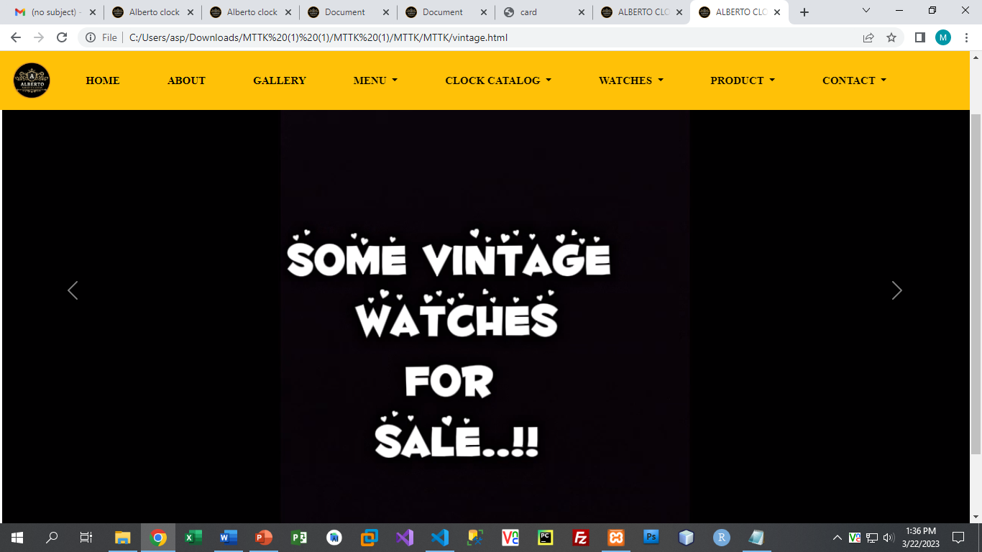

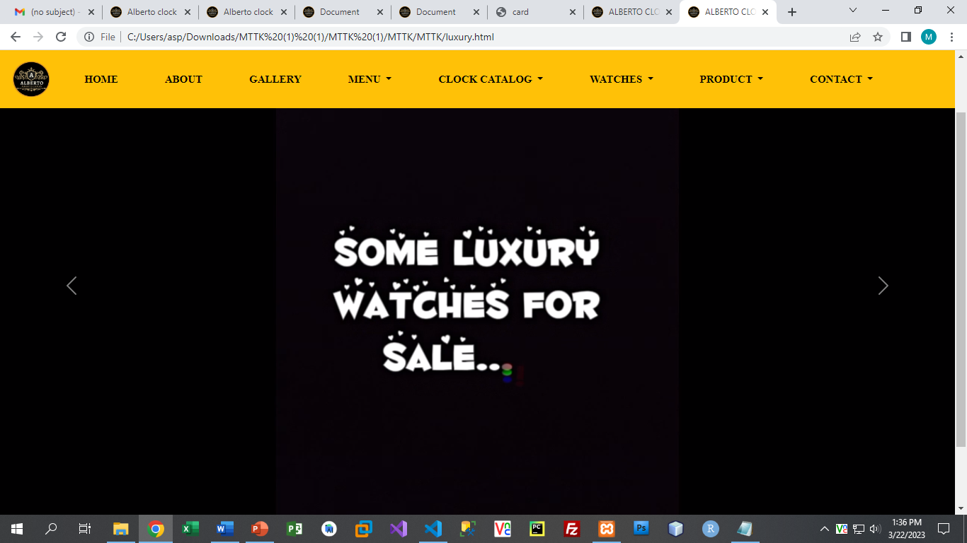

Gallery

CONTENT

THE IMAGE GALLERY

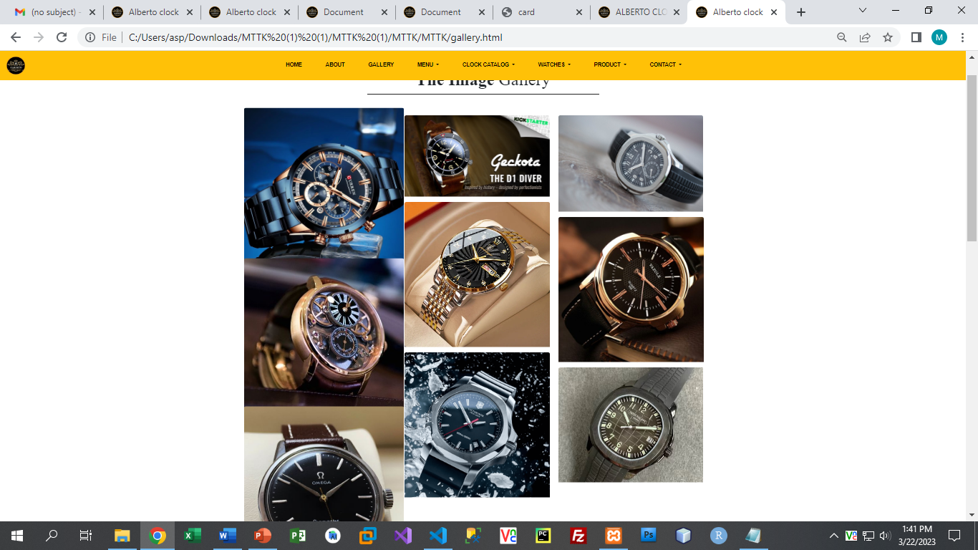

CONTENT

Contact

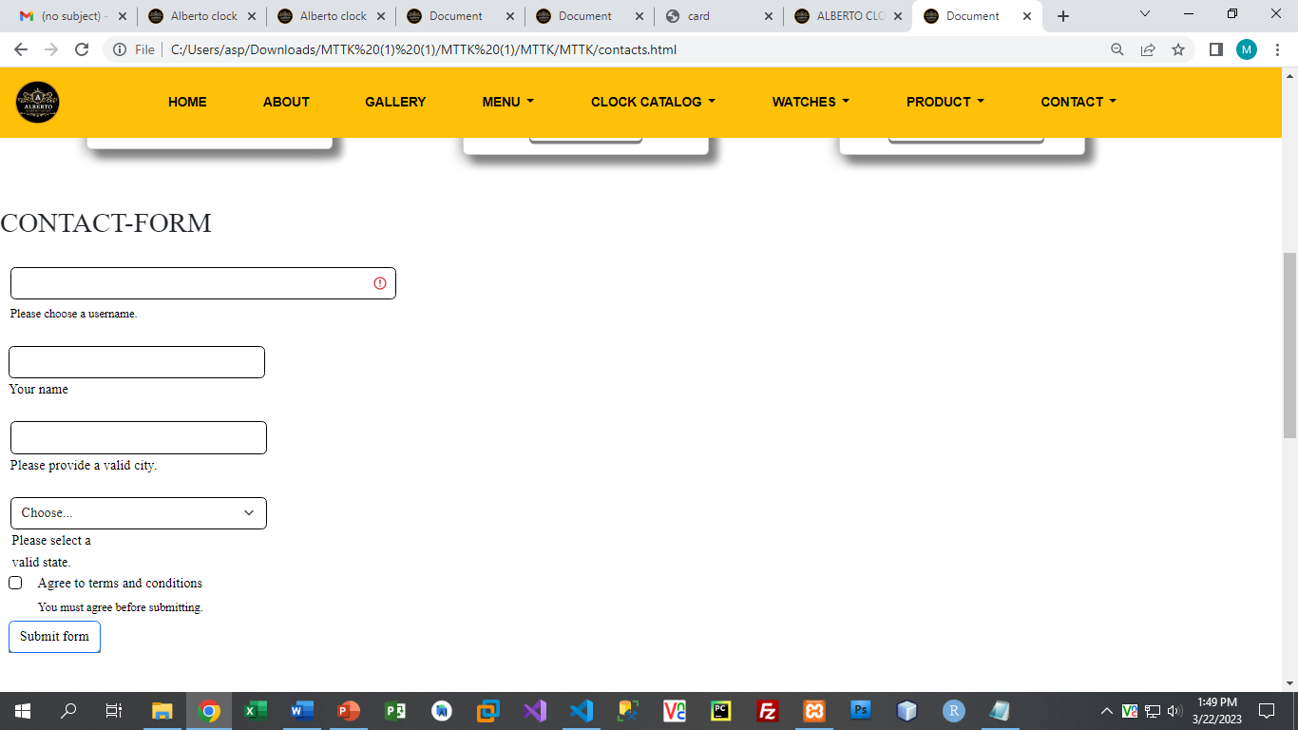

Site Map

Map

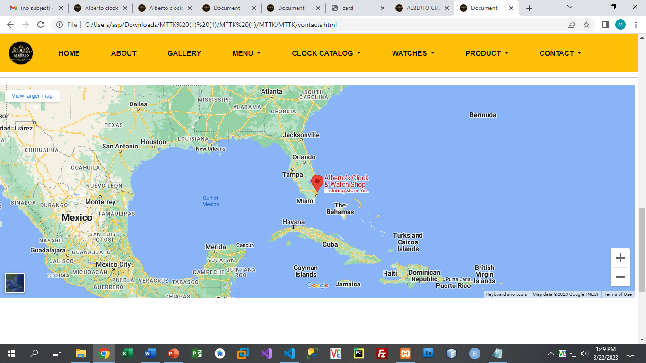

QUESTIONS:

FOOTER:

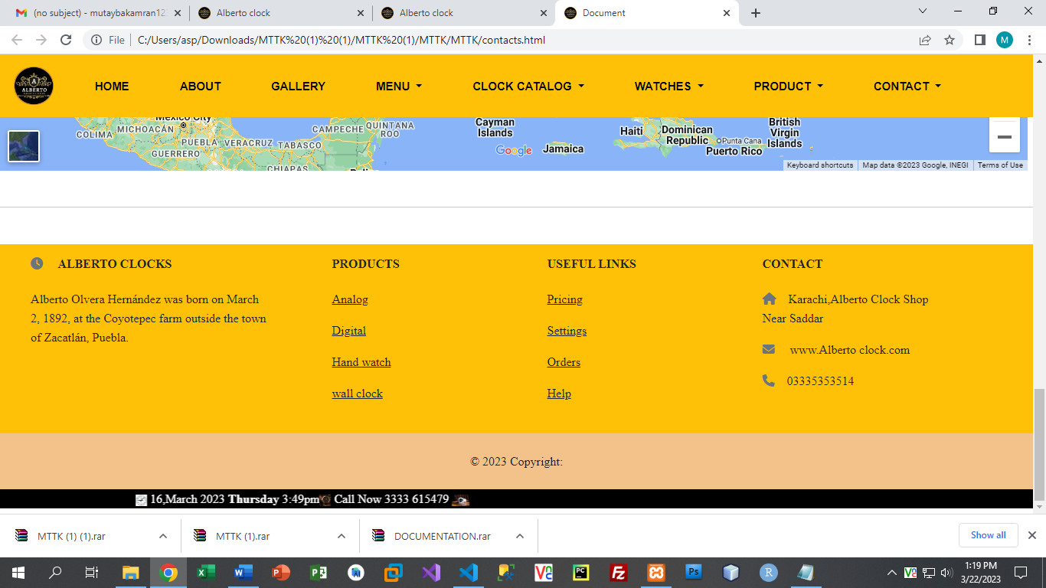

Our Footer

***TASK SHEET REVIEW 2***

|  |  |  |  |  |  |  |
| --- | --- | --- | --- | --- | --- | --- |
| Project Ref. No.: eP/Advertisement Portal Management System/01 | | Project  title | Date of Preparation of Activity Plan | | | |
| No | Task | Alberto  Clocks | Actual | Actual | Team-mate | Status |
| Start Date | Days | Names |
| 1 | Build  Home, About Page | 25/Feb/23 | 4 | Talha | Complete |
| 2 | Build  Product,  Watches,  Gallery  Page | 25/Feb/23 | 4 | Tayyaba | Complete |
| 3 | Build  Menu,  Clock catalog,  Contact-us  Page | 27/Feb/23 | 4 | Mutayba | Complete |
| 4 | Build , attractive  Contents | 25/Feb/23 | 7 | Talha,  Tayyaba | Complete |
| 5 | Found pictures | 25/Feb/23 | 2 | Talha,  Tayyaba | Complete |
| 6 | Build Code of  JavaScript for Onclick | 25/Feb/23 | 3 | Tayyaba | Complete |
| 7 | Build Code  JavaScript for  Scrollng Ticker | 25/Feb/23 | 3 | Talha | Complete |

|  |  |  |  |  |  |  |
| --- | --- | --- | --- | --- | --- | --- |
|  |  |  |  |  |  |  |
| 8 | Check Progress and Assign New Tasks | Every Alternative Day | - | Talha,  Mutayba,  Tayyaba. | Complete |

***TASK SHEET REVIEW 3***

|  |  |  |  |  |  |  |
| --- | --- | --- | --- | --- | --- | --- |
| Project Ref. No.: eP/Advertisement Portal Management System/01 | | Project title | Date of Preparation of Activity Plan | | | |
| No | Task | Alberto  clocks | Actual  Start Date | Actual  Days | Team-mate  Names | Status |
| 1 | Check color  format, size,  JavaScript, Bootstrap, CSS  responsive in the Home page create Navbar and logo | 25/Feb/22 | 4 | Tayyaba Muslim | Complete |
| 2 | Check color  format, size,  JavaScript, Bootstrap, CSS  responsive in  Menu,Products | 25/Feb/22 | 4 | Mutayba Kamran | Complete |
| 3 | Check color  format, size,  JavaScript,  responsive in  Portfolio, arrival page. | 25/Feb/22 | 4 | Muhammad Talha | Complete |
| 4 | Write a  developer guide and web content | 25/Feb/22 | 9 | Khula  Amjad | Complete |
|  |  |
| 6 | Overall  inspection of the project | 25/Feb/22 | 1 | Talha Tayyaba Mutayba and khaula | Complete |